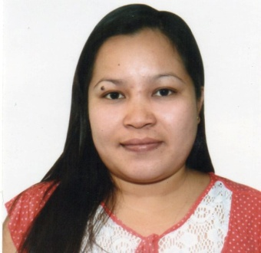**MERALYN C. ASIS – AROY**

B24 Lot 6 Recomville II Brgy. Deparo, Caloocan City

Contact #: 09158331340

***OBJECTIVE***

To obtain an entry level position in any work that I will be qualified which will utilize and enhance my abilities.

***PERSONAL INFORMATION***

Nickname : Merai

Date of Birth : April 16, 1985

Place of Birth : Manhilo, Maasin City, Southern Leyte

Sex : Female

Civil Status : Married

Citizenship : Filipino

Religion :Roman Catholic

Height : 1.58 m.

Weight : 65 kg.

Blood Type :“A”

Mother : Mercedita Catedral – Asis

Father : Alfredo Resos Asis

Husband : Ronaldo C. Aroy Jr.

***EDUCATIONAL BACKGROUND***

COLLEGE: Saint Joseph College

Bachelor of Science in Computer Science

Maasin City, Southern Leyte

Year Graduated:October 2006

SECONDARY: Guadalupe National High School

Guadalupe,Maaasin City, Southern Leyte

Year Graduated: March 2002

ELEMENTARY: Guadalupe Elementary School

Guadalupe, Maasin City, Southern Leyte

Year Graduated: March 1998

***WORK EXPERIENCES***

* **Electronic Data Processing (EDP) Staff / Inventory Clerk**

Progress Home & Office Furnishings – Iloilo branch

Lopez Jeana St., Lapaz, Iloilo City

February 2010 – June 2014

* **Assistant Store Personnel**

Cebu Belmont Inc.

Cebu City

November 2009 - February 2010

* **Indexer/Abstractor**

Innodata Knowledge Services Inc.

Subangdaku, Mandaue City

February 2008 – July 2009

* **Apprentice / Factory Worker**

Republic Biscuit Corp. (REBISCO)

Alae, Manolo Fortich, Bukidnon

November 2007 – January 2008

* **Cashier**

National Bookstore / Abacus Book& Card Corp.

Borja St., Cogon, Cagayan De Oro City

April 2007 – September 2007

***REFERENCES***

**Mr. Roderick Pakson**

Branch Manager

Progress Home & Office Furnishings

**C**ontact # (032) 418-4569

**Mr. Edgardo Rosales**

HR Manager

Progress Home & Office Furnishings

Colon St., Cebu City

Contact # (032)418-4902

Signature